**Assignment 17**

**Name:** Jeevan Sai Badana

**Mail:** jeevansai100@gmail.com

**Topic:** Visualization in databricks

**Date: 13-02-2024**

**Visualization in databricks:**

Visualization in Databricks refers to the process of creating graphical representations of data stored and analyzed within the Databricks environment. These visualizations help data scientists, analysts, and other users to gain insights, identify patterns, and communicate findings more effectively.

For this purpose first we read one csv file data as follows

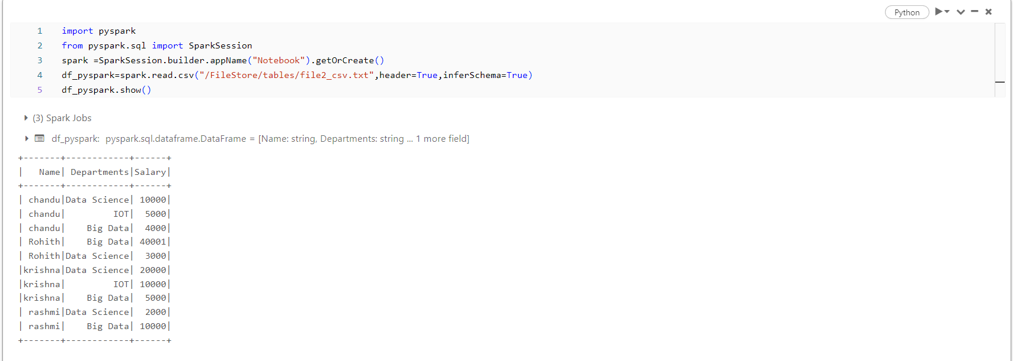

Now we do visualization by using display(df_pyspark)

